Problem no 01: “Even or odd”
#include <stdio.h>
int main ()
{
int n;
printf("Inter the value of n=\n");
scanf("%d", &n);
if (n % 2 == 0) {
printf("Even");
} else
{
printf("Odd");
}
return 0;
}

Output:
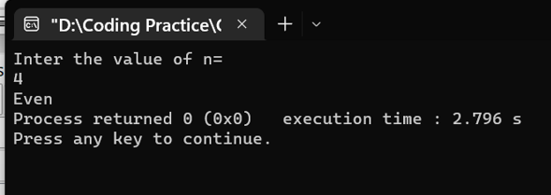
Problem no 2: “Divisibility by 3 or 4”
#include <stdio.h>
int main() {
int n;
printf("Inter the value of n = ");
scanf("%d", &n);
if (n % 2 == 0) {
printf("Even ");
if (n % 4 == 0) {
printf("and divisible by 4");
} else {
printf("and not divisible by 4");
}
} else {
printf("Odd ");
if (n % 3 == 0) {
printf("and divisible by 3");
} else {
printf("and not divisible by 3");
}
}
return 0;
}

Output:
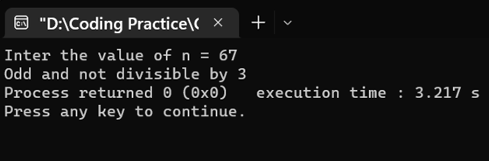

Problem no 03 : “ Checking the equal number”
#include <stdio.h>
int main() {
int a, b, c;
printf("inter the value of a,b and c =");
scanf("%d %d %d", &a, &b, &c);
if (a == b) {
if (a == c) {
printf("Yes");
} else {
printf("No");
}
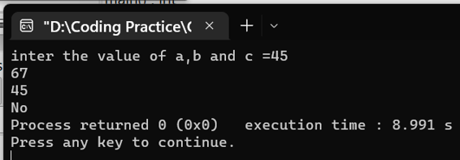
} else {
printf("No");
}
return 0;

Problem no 04 : “Checking maximum number”
#include <stdio.h>
int main() {
int a, b, c;
printf("Inter the value of a,b and c");
scanf("%d %d %d", &a, &b, &c);
if (a > b) {
if (a > c) {
printf("%d", a);
} else {
printf("%d", c);
}
} else {
if (b > c) {
printf("%d", b);
} else {
printf("%d", c);
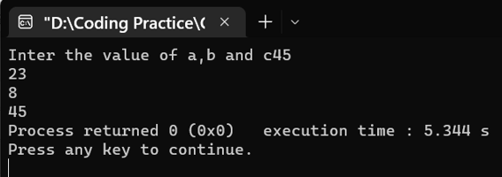
}
}
return 0;
}

Problem no 05 : “Greading system”
#include <stdio.h>
int main() {
int marks;
printf("Inter the marks =");
scanf("%d", &marks);
if (marks >= 35) {
if (marks >= 90) {
printf("A+");
} else if (marks >= 80) {
printf("A");
} else if (marks >= 70) {
printf("B");
} else if (marks >= 60) {
printf("C");
} else {
printf("D");
}
} else {
printf("F");
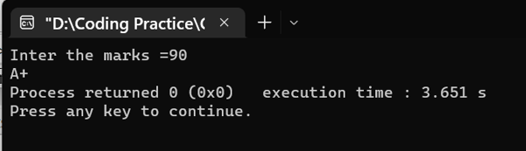
}
return 0;
}

Problem no 06 : “ Checking Leap year”

#include <stdio.h>
int main() {
int year;
lavel: printf("Inter the year =");
level: scanf("%d", &year);
if (year % 4 == 0) {
if (year % 100 == 0) {
if (year % 400 == 0) {
printf("Leap year");
} else {
printf("Not a leap year");
}
} else {
printf("Leap year");
}
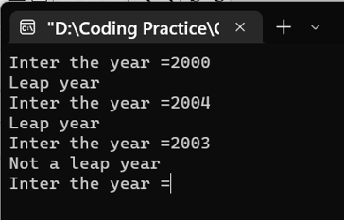
} else {
printf("Not a leap year");
}
goto lavel;
goto level;
return 0;
}
Problem no 07 : “ Enable for voting or not “
#include<stdio.h>
int main()
{
int age;
level:printf("Inter the age :");
lavel:scanf("%d",&age);
if (age>=18){
printf("Eligible for voting\n");
}
else
{
printf("Not eligible for voting\n");
}
goto level;
goto lavel;
return 0;
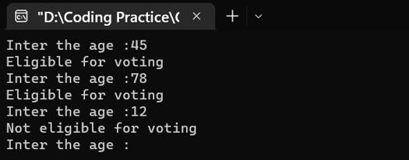

Problem no 08: “Writing a week list using “switch case”

#include <stdio.h>
int main()
{
int week;
level: printf("Enter week number ");
scanf("%d", &week);
switch(week)
{
case 1:
printf("Saturday\n");
break;
case 2:
printf("Sunday\n");
break;
case 3:
printf("Monday\n");
break;
case 4:
printf("Tuesday\n");
break;
case 5:
printf("Wednesday\n");
break;
case 6:
printf("Thursday\n");
break;
case 7:
printf("Friday\n");
break;
default:
printf("Invalid input!\n");
}
goto level;
return 0;
}

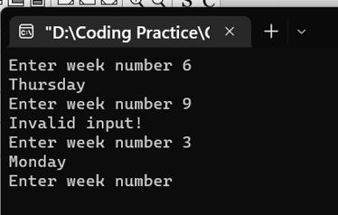

Problem no 09: “Program to print number of days in month using “switch-case”

#include <stdio.h>
int main() {
int month;
lavel: printf("Enter month number: ");
scanf("%d", &month);
switch(month){
case 1:
printf("31 days\n");
break;
case 2:
printf("28 days\n");
break;
case 3:
printf("31 days\n");
break;
case 4:
printf("30 days\n");
break;
case 5:
printf("31 days\n");
break;
case 6:
printf("30 days\n");
break;
case 7:
printf("31 days\n");
break;
case 8:
printf("31 days\n");
break;
case 9:
printf("30 days\n");
break;
case 10:
printf("31 days\n");
break;
case 11:
printf("30 days\n");
break;
case 12:
printf("31 days\n");
break;
default:
printf("Invalid input!\n ");
}
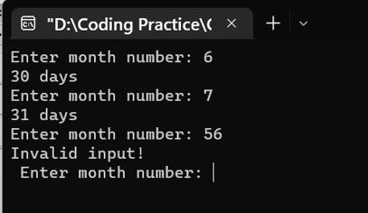
goto lavel;
return 0;
}

Bangladesh University of Business & Technology



Lab Report: 04
Course Title: Structured Programming Language Lab Code: CSE-112

Submitted By | Submitted To
Name: Rakibul Islam Asif  ID: 22235103319  Intake:51, Section:8 Department of CSE | Name: Md. Saddam Hossain.  Assistant Professor  Department of CSE BUBT

